**Lab Exercise 8– Creating a VPC in Terraform Objective:**

**Objective:**

Learn how to use Terraform to create a basic Virtual Private Cloud (VPC) in AWS.

**Prerequisites:**

* Terraform installed on your machine.
* AWS CLI configured with the necessary credentials.

**Steps:**

**1. Create a Terraform Directory:**

**mkdir terraform-vpc**

**cd terraform-vpc**

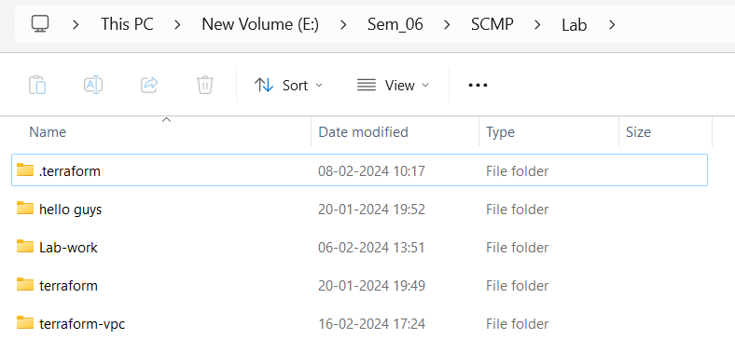

* Create Terraform Configuration Files:
* Create a file named main.tf:

# main.tf

|  |
| --- |
| **provider "aws" { region = "us-east-1"**  **}**    **resource "aws_vpc" "my_vpc" { cidr_block = "10.0.0.0/16" enable_dns_support = true enable_dns_hostnames = true**    **tags = {**  **Name = "MyVPC"** |
| **}**  **}**    **resource "aws_subnet" "my_subnet" { count = 2**    **vpc_id = aws_vpc.my_vpc.id**  **cidr_block = "10.0.${count.index + 1}.0/24" availability_zone = "us-east-1a" map_public_ip_on_launch = true**    **tags = {**  **Name = "MySubnet-${count.index + 1}"**  **}**  **}** |

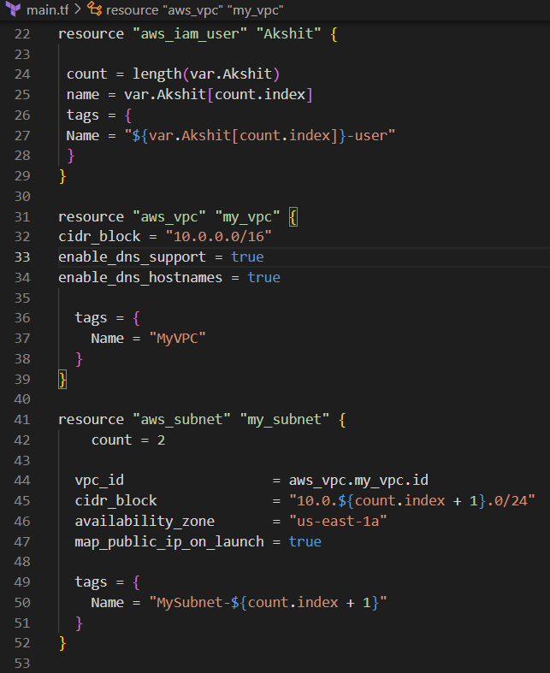

In this configuration, we define an AWS provider, a VPC with a specified CIDR block, and two subnets within the VPC.

**2. Initialize and Apply:**

* Run the following Terraform commands to initialize and apply the configuration:

**terraform init terraform apply**

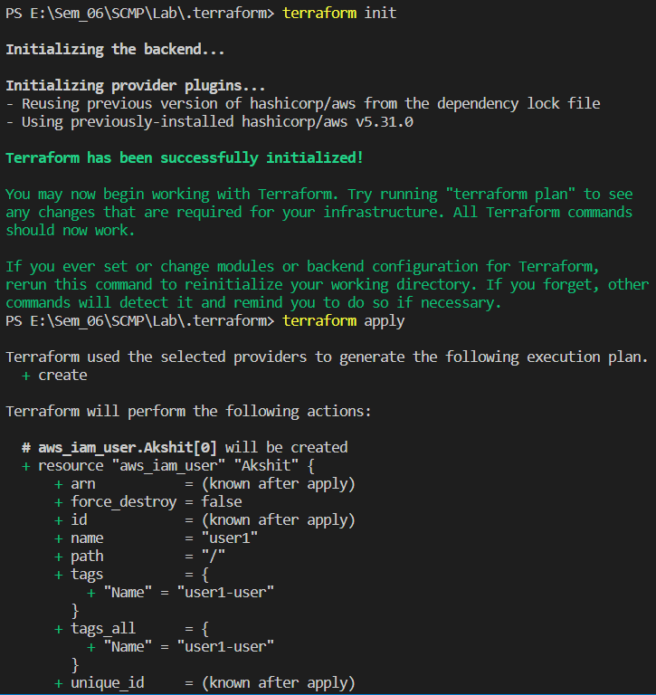

Terraform will prompt you to confirm the creation of the VPC and subnets. Type yes and press Enter.

**3. Verify Resources in AWS Console:**

* Log in to the AWS Management Console and navigate to the VPC (Virtual private cloud) service.
* Verify that the VPC and subnets with the specified names and settings have been created.

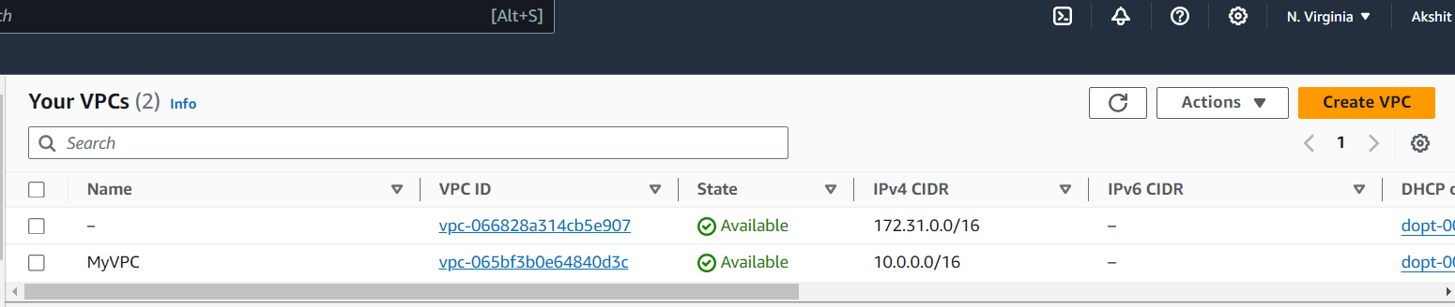

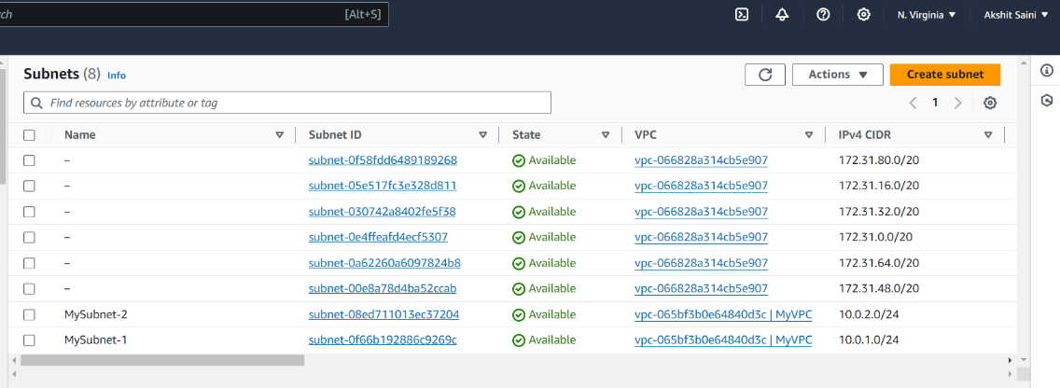

**4. Update VPC Configuration:**

* If you want to modify the VPC configuration, update the main.tf file with the desired changes.
* Re-run the terraform apply command to apply the changes:

**terraform apply**

1. **Clean Up:**

After testing, you can clean up the VPC and subnets:

**terraform destroy**

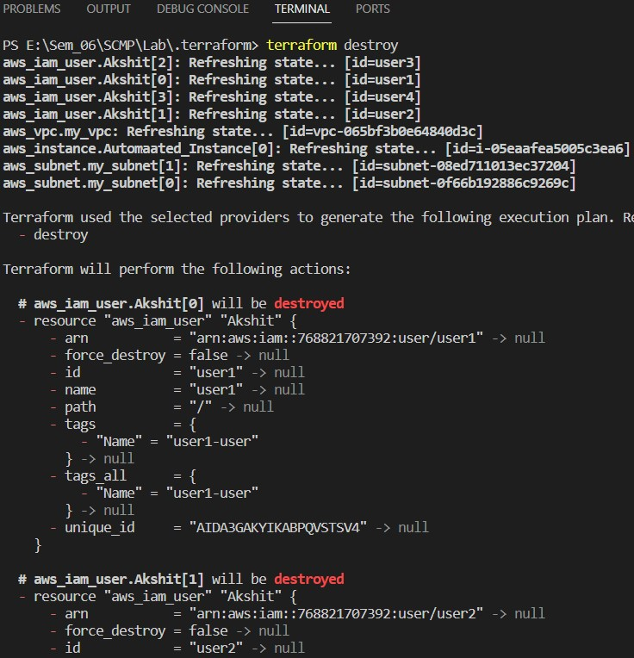

Confirm the destruction by typing yes.

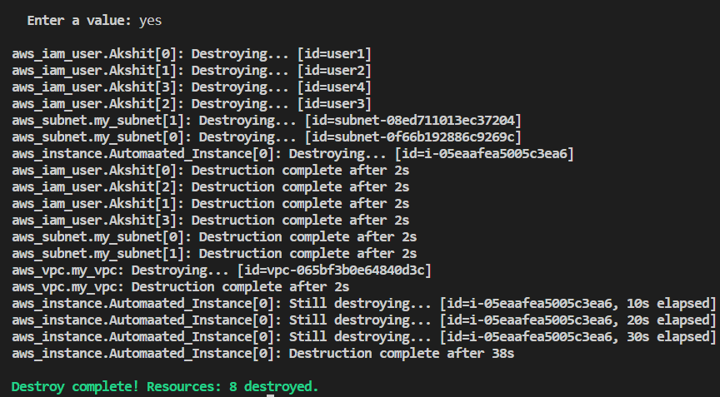

1. **Conclusion:**

This lab exercise demonstrates how to create a basic Virtual Private Cloud (VPC) with subnets in AWS using Terraform. The example includes a simple VPC configuration with two subnets. Experiment with different CIDR blocks, settings, and additional AWS resources to customize your VPC.